**Project**

**Design**

**Phase-II**

**Data**

**Flow**

**Diagram**

**&**

**User**

**Stories**

Date

16

October

2022

Team

ID

PNT2022TMID

34648

Project

Name

Personal

Expense

Tracker

Application

Maximum

Marks

4

Marks

**Data**

**Flow**

**Diagrams:**

A

Data

Flow

Diagram

)

(

DFD

is

a

traditional

visual

representation

of

the

information

flows

within

a

system.

A

neat

and

clear

DFD

can

depict

the

right

amount

of

the

system

requirement

graphically.

It

shows

how

data

enters

and

leaves

the

system,

what

changes

the

information,

and

where

data

is

stored.

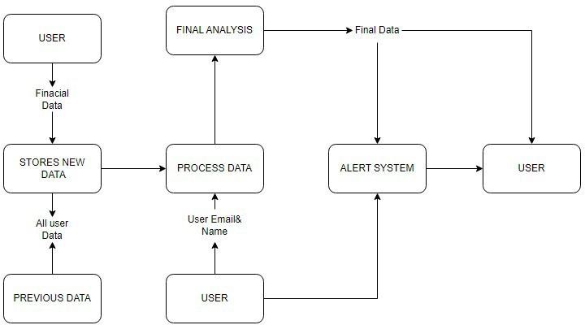

|  |  |  |  |  |  |  |  |  |  |  |  |  |  |  |  |  |  |  |  |  |  |  |  |  |  |  |  |  |  |  |  |  |  |  |  |  |  |  |  |  |  |  |  |  |  |  |  |  |  |  |  |  |  |  |  |  |  |  |  |  |  |  |  |
| --- | --- | --- | --- | --- | --- | --- | --- | --- | --- | --- | --- | --- | --- | --- | --- | --- | --- | --- | --- | --- | --- | --- | --- | --- | --- | --- | --- | --- | --- | --- | --- | --- | --- | --- | --- | --- | --- | --- | --- | --- | --- | --- | --- | --- | --- | --- | --- | --- | --- | --- | --- | --- | --- | --- | --- | --- | --- | --- | --- | --- | --- | --- | --- |
| **User Stories**  Use the below template to list all the user stories for the product.   |  |  |  |  |  |  |  | | --- | --- | --- | --- | --- | --- | --- | | **User Type** | **Functional**  **Requirement (Epic)** | **User Story Number** | **User Story / Task** | **Acceptance criteria** | **Priority** | **Release** | | Customer  (Mobile user  & web user ) | Registration | USN-1 | As a user, I can register for the application by entering my email, and password, and confirming my password. | I can access my account/dashboard | High | Sprint-1 | |  |  | USN-2 | As a user, I will receive a confirmation email once I have registered for the application | I can receive a confirmation email & click confirm | High | Sprint-1 | |  |  | USN-3 | As a user, I can register for the application through Facebook3 | I can register & access the dashboard with Facebook Login | Low | Sprint-2 | |  |  | USN-4 | As a user, I can register for the application through a Google account. | I can register & access the dashboard with a  Google Account login. | Medium | Sprint-1 | |  | Login | USN-5 | As a user, I can log into the application by entering my email & password | I can access the application. | High | Sprint-1 | |  | Dashboard | USN-6 | As a user, I can see the daily expenses and expenditure details. | I can view the daily expenses and add the expense details. | High | Sprint-1 | | Customer Care Executive |  | USN-7 | As a customer care executive ,it is easy to solve the problem that faced by the customers. | I can provide support to customers at any time 24*7. | Medium | Sprint-1 | | Administrator | Application | USN-8 | As an administrator, I can update the application and provide necessary upgrades. | I can fix any bugs raised by customers and upgrade the application. | Medium | Sprint-1 | |